SCCR/42/3
ORIGINAL: English
DATE: March 4, 2022
Standing Committee on Copyright and Related Rights
Forty-Second Session
Geneva, May 9 to 13, 2022
REVISED DRAFT TEXT FOR THE WIPO BROADCASTING ORGANIZATIONS TREATY
prepared by the SCCR Acting Chair in cooperation with the SCCR Vice-Chair and facilitators

REVISED DRAFT TEXT
Introductory Note

The issue of an enhanced and updated protection for broadcasting organizations concerning their programme-carrying signals has been on the agenda of the World Intellectual Property Organization since 1998, when the Standing Committee on Copyright and Related Rights (SCCR) was established. The preparatory process was initiated at the WIPO Worldwide Symposium on Broadcasters’ Rights which was held in Manila in 1997 which preceded the establishing of the SCCR.

The matter has regularly been on the agenda of the WIPO General Assembly since 1998. The General Assembly has taken note of the substantial work done in the SCCR and has on a number of occasions requested the SCCR to accelerate its work with the aim of agreeing on and finalizing a treaty on a signal-based approach, the objectives, specific scope, and object of the protection with a view to convening a diplomatic conference.

In the SCCR, the Chair started in 2015 to maintain a consolidated text on definitions, object of protection, rights to be granted and other issues. This document was processed in both the plenary sessions of the Committee, as well as on the basis of discussions in the informal consultations involving all regional groups of WIPO.

The revised consolidated text on definitions, object of protection, rights to be granted and other issues, prepared by the Chair (SCCR/39/7) was taken as the basis of the preparation of this Revised Drat Text for a WIPO Broadcasting Organizations Treaty.

The text now presented is just a draft text, a next step from the previous document (SCCR/39/7) forward. There is no agreement between the Member States on any elements in its content, and they are open for changes based on the discussions in the Committee.

The ambition in the new Chair’s text is that the number of alternative provisions in the text would be kept as limited as possible.

Similarly, the ambition is to keep the number of suggested agreed statements in a minimum. This means that there is a maximum effort to draft the text of the articles in a most clear and succinct manner. The instrument of agreed statements would in this way saved for the negotiations in a Diplomatic Conference.

Finally, it should be stressed that once, when the Committee decides about the preparation of a proposal to be presented to the Diplomatic Conference, also that text will be a draft, subject to change in the conference itself.

The Draft text now on table, has been prepared during the difficult situation where COVID19 has made impossible all normal international work - in order to provide basis for the next steps of the work of the SCCR when the working situation allows a normal meeting activity.

The Explanatory Notes are not part of the Draft Treaty but merely explanations for the understanding and interpretation of the provisions of the Draft Treaty.

The following drawings are intended to illustrate the different uses of the programme-carrying signals of the broadcasting organizations. The protection under this Treaty would provide protection for the broadcasting organizations in these situations against unauthorized or unlawful uses of the signal by third persons. As the protection is international, a border between states is, in the illustrations, placed so that the original broadcasting organization is situated in country A, and the users are situated in country B. The cases of use may consist of very complex chains of transmissions. The drawings are deliberately simplified.

Retransmission

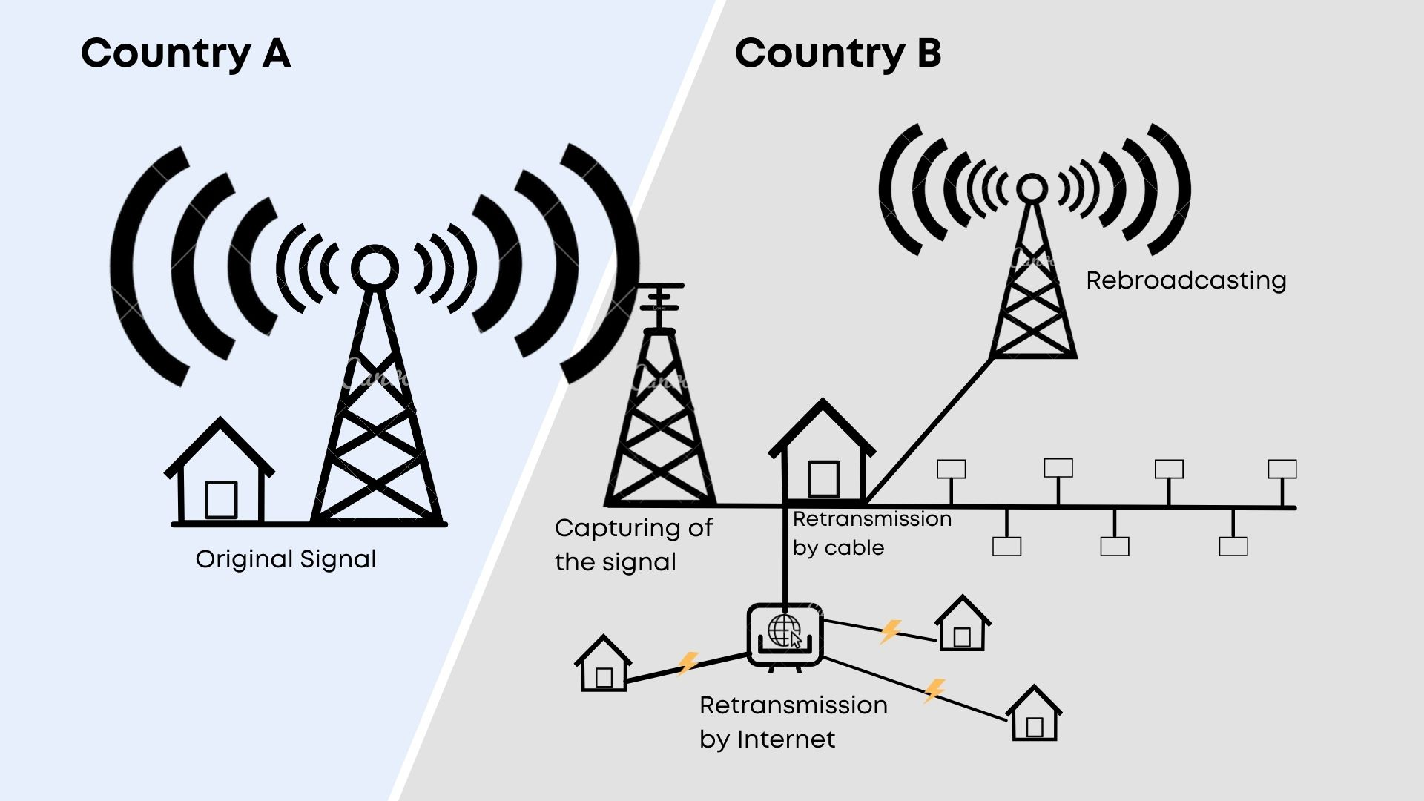

Deferred transmission of stored programmes by the original broadcasting organization

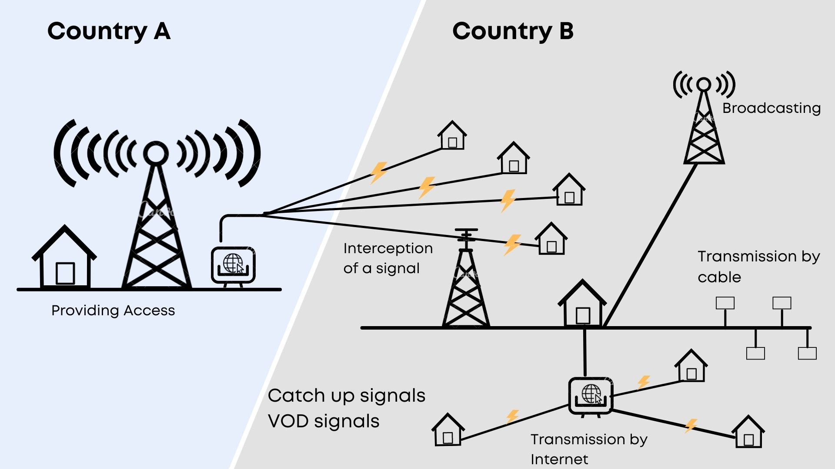

Deferred transmission of stored programmes
by another entity than the original broadcasting organization

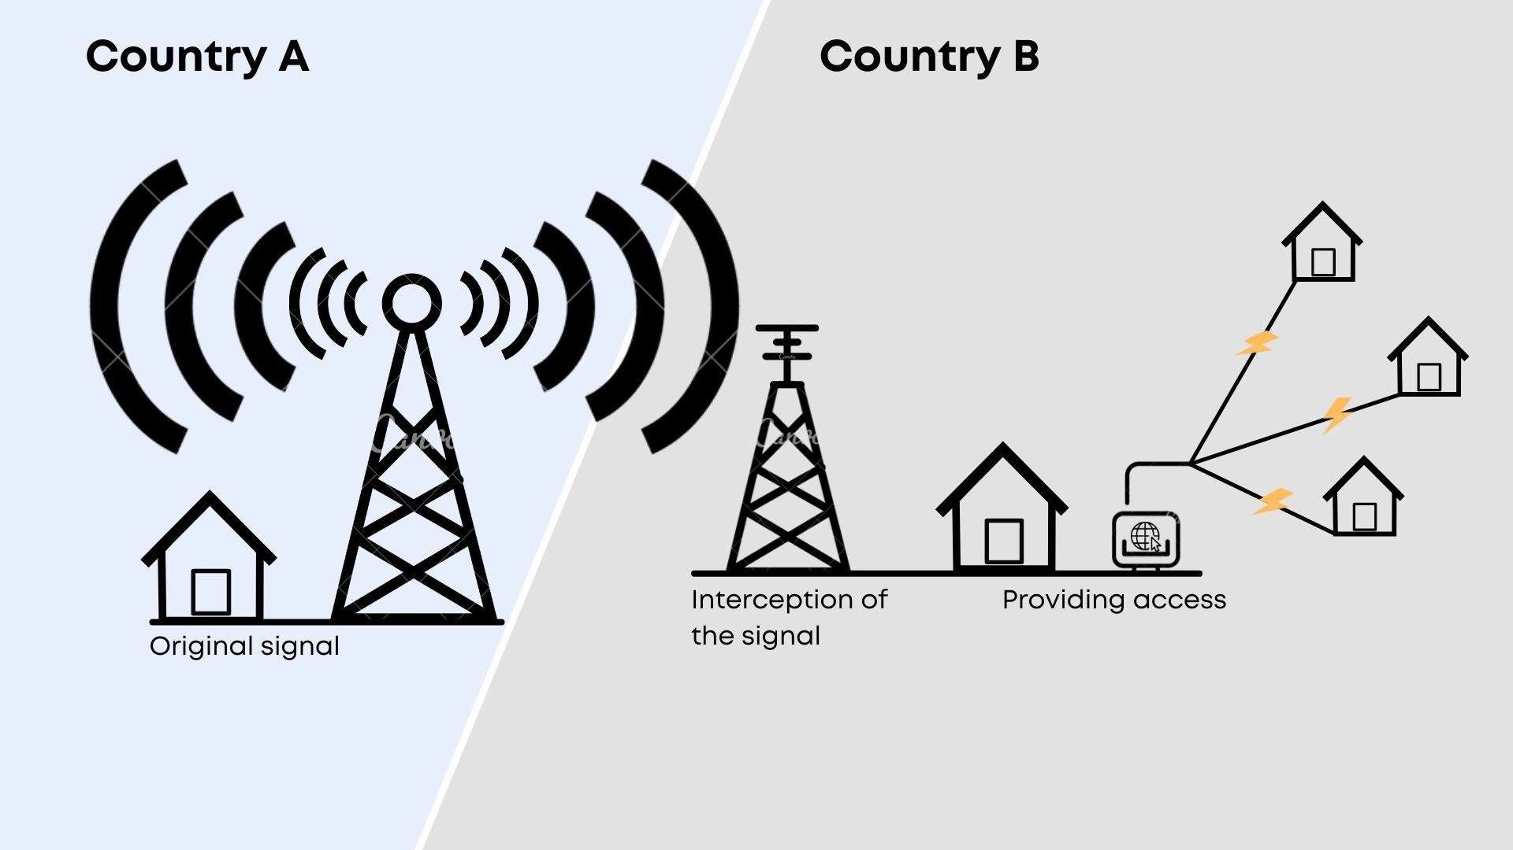

Interception of pre-broadcast signals

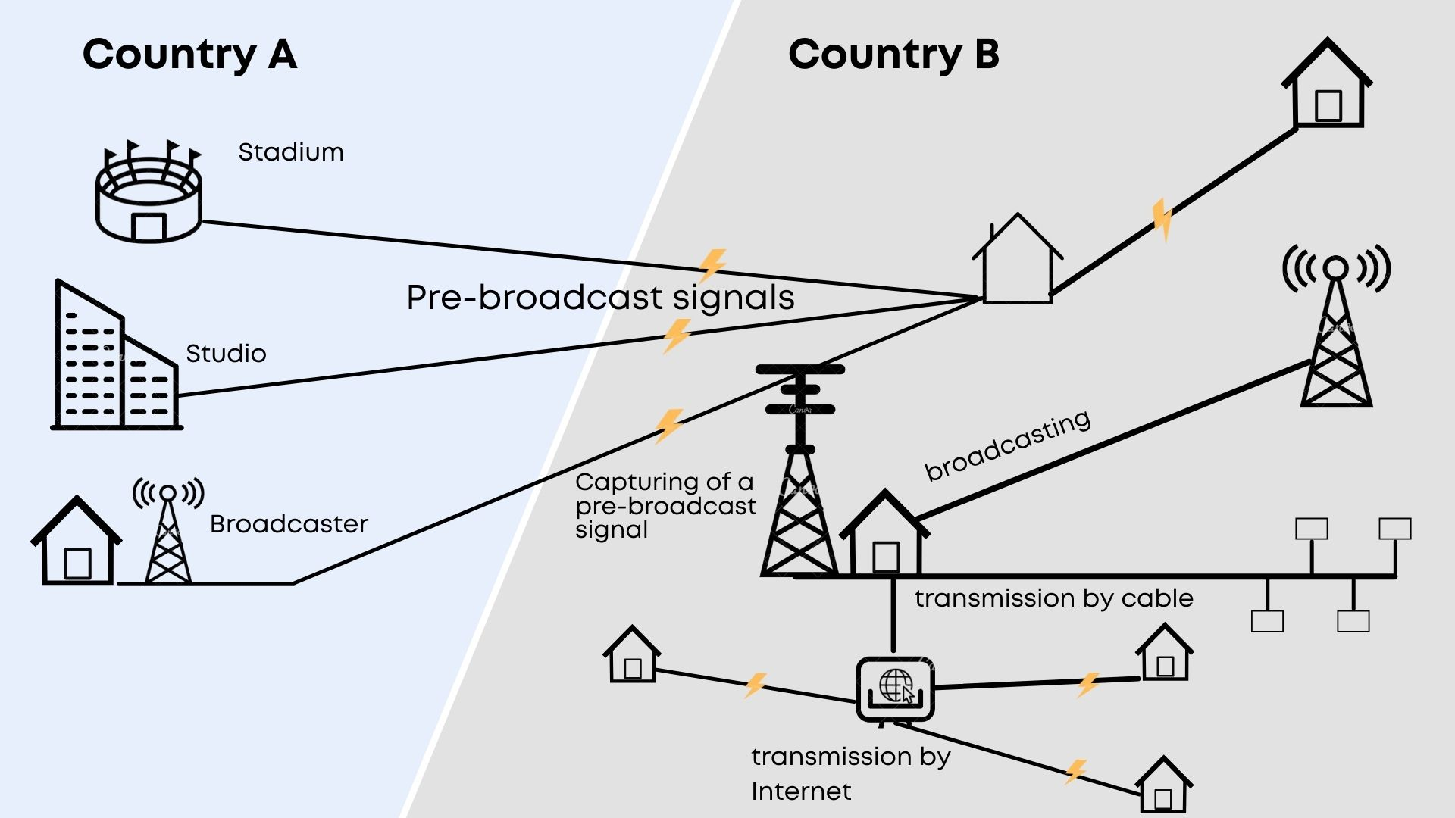

[Revised Draft Text follows]

Revised Draft Text for the
WIPO Broadcasting Organizations Treaty

Contents

Preamble 7

GENERAL PROVISIONS

Article 1 – Relation to Other Conventions and Treaties 9

Article 2 – Definitions 11

Article 3 – Scope of Application 15

Article 4 – Beneficiaries of Protection 17

Article 5 – National Treatment 19

SUBSTANTIVE PROVISIONS

Article 6 – Right of Retransmission…. 21

Article 7 – Deferred Transmission of Stored Programmes 23

Article 8 – Pre-broadcast Signals 25

Article 9 – Other Adequate and Effective Protection 27

Article 10 – Limitations and Exceptions 29

Article 11 – Term of Protection 31

Article 12 – Obligations Concerning Technological Measures 33

Article 13 – Obligations Concerning Rights Management Information 35

Article 14 – Formalities 37

Article 15 – Reservations 39

Article 16 – Application in Time 41

Article 17 – Provisions on Enforcement of Rights of Broadcasting Organizations 43

Article 18 – Provisions on Enforcement of Copyrights and Related Rights 45

Explanatory Notes on the Preamble

0.01 The Preamble sets forth the objective of the Treaty and the main arguments and considerations relating thereto.

0.02 The first paragraph of the Preamble follows mutatis mutandis the first paragraph of the WPPT which took its inspiration from the first paragraph of the preamble of the Berne Convention for the Protection of Literary and Artistic Works (the Berne Convention).

0.03 The second paragraph follows mutatis mutandis the third paragraph of the preamble of the WPPT. The reference to “unauthorized use of programme-carrying signals of broadcasting organizations” emphasizes the anti-piracy function of the Treaty. Unauthorized use of programme-carrying signals is a phenomenon that appear in Contracting parties both on the domestic level and cross-border between the Contracting Parties.

0.04 The third paragraph emphasizes the fact that the Treaty focuses on the intellectual property type protection of the programme-carrying signals of the broadcasting organizations. Thus neither the definitions nor the substantive provisions of the Treaty do not interfere in or affect the Contracting Parties’ national regulatory framework of broadcasting activities. Such regulation is normally based on public law.

0.05 The fourth paragraph sets the high objective not to compromise but to recognize the rights of the owners of the content carried by broadcasts.

0.06 The fifth paragraph stresses the benefits of the effective protection of broadcasting organizations against illegal use of programme-carrying signals to rightholders of the programmes carried by the signals.

[End of Explanatory Notes on the Preamble]

Preamble

The Contracting Parties,
Desiring to develop and maintain the international protection of the rights of broadcasting organizations in a manner as balanced and effective as possible,

Recognizing the profound impact of the development and convergence of information and communication technologies which have given rise to increasing possibilities for unauthorized use of the programme-carrying signals of broadcasting organizations both within and across borders,

Emphasizing that this instrument focuses on the legal protection of the programme-carrying signals of the broadcasting organizations, and that its provisions do not affect the Contracting Parties’ national regulatory framework for broadcasting activities,

Recognizing the objective to enhance the international system of protection of broadcasting organizations without compromising copyright in works and related rights in other protected subject matter incorporated in the programme-carrying signals, as well as the need for broadcasting organizations to acknowledge these rights,

Stressing the benefits to authors, performers and producers of phonograms of effective protection by the broadcasting organizations against illegal use of programme-carrying signals,
Have agreed as follows:
[End of Preamble]

Explanatory Notes on Article 1

1.01 The provisions of Article 1 concern the nature of the Treaty and defines its relation to copyright in the literary and artistic works as well as related rights in other protected subject matter under existing conventions and treaties. Such works and other subject matter may be incorporated in the programmes carried by the signals of broadcasting organizations.

1.02 Paragraph (1) of Article 1 contains a “non-prejudice clause” concerning the protection of copyright and related rights following the model of Article 1 of the Rome Convention, Article 1(2) of the WPPT, as well as Article 1(2) of the BTAB. The protection under this Treaty shall leave intact and shall in no way affect, limit or prejudice the protection of copyright or related rights under the Berne Convention, WPPT, or BTAP.

1.03 The provisions of this Article, as well as the provisions in Article 3(1) clarify the relationship between rights in programme-carrying signals under this Treaty and rights in the content embodied in such signals. In cases where authorization is needed from both the rights holder of content embodied in such a signal and a broadcasting organization, the need for the authorization of the right holder does not cease to exist because the authorization from the broadcasting organization is also required, and vice-versa.

1.04 Furthermore, the rights granted to broadcasting organizations under this Treaty may not be invoked against the holder of rights in the content and, in particular, may not deprive them of the ability to control, by contract, the relations with broadcasting organizations and to exploit content contained in programme-carrying signals independently.

1.05 Paragraph (2) of Article 1 contains a “Rome safeguard clause” following the model of Article 1(1) of the WPPT, and Article 1(1) of the BTAP. It should be understood that this provision, when making reference only to the Rome Convention, does not advocate that this new Treaty would derogate from existing obligations under any other treaty.

1.06 Paragraph (3) makes a reference to Article 22 of the Rome Convention. Under Article 22 of the Rome Convention the Contracting States of that Convention reserve the right to enter into special agreements to grant, inter alia, to broadcasting organizations, “more extensive rights that those granted by this Convention or contain other provisions not contrary to this Convention”. The rights granted in this new Treaty are partly overlapping, partly more extensive, and partly less extensive than those granted in the Rome Convention. The provisions of this Treaty are definitely neither contrary to the provisions of the Rome Convention. The purpose of the provision of Paragraph (3) is to make clear that this new Treaty is a free-standing new Treaty and not linked to the Rome Convention.

1.07 Paragraph (4) contains a clarification according to which the Contracting Parties that are also Contracting States of the Rome Convention continue to apply between themselves the provisions of that Convention in cases where its obligations are more extensive than the obligations of this Treaty.

1.08 Paragraph (5) recognizes that the protection based on copyright or related right in certain provisions of the Treaty is internationally governed by the Berne Convention, the WCT, the WPPT or the BTAP.

[End of Explanatory Notes on Article 1]
Article 1
Relation to Other Conventions and Treaties

(1) Protection granted under this Treaty shall leave intact and shall in no way affect, limit or prejudice the protection of copyright in literary or artistic works under the Berne Convention for the Protection of Literary and Artistic Works (hereinafter the Berne Convention), WIPO Copyright Treaty (hereinafter the WCT), or related rights in other protected subject matter under the WIPO Performances and Phonograms Treaty, done in Geneva on December 20, 1996 (hereinafter the WPPT), and Beijing Treaty on Audiovisual Performances, done in Beijing on June 24, 2012 (hereinafter the BTAP). Consequently, no provision of this Treaty may be interpreted as prejudicing such protection.

(2) Nothing in this Treaty shall derogate from existing obligations that Contracting Parties have to each other under the International Convention for the Protection of Performers, Producers of Phonograms and Broadcasting Organizations done in Rome, October 26, 1961 (hereinafter the Rome Convention).

(3) This Treaty is not a special agreement under Article 22 of the Rome Convention.

(4) Contracting Parties, who are Contracting States of the Rome Convention, will apply the provisions of the Rome Convention between themselves when that Convention provides for an obligation which is more extensive than the obligations of this Treaty.

(5) The Berne Convention, the WCT, the WPPT, and the BTAP are, when relevant, applicable to protection based on copyright or related rights under the provisions of Article 9(1), 9(2), and 18.
[End of Article 1]
Explanatory Notes on Article 2

2.01 Article 2 contains definitions of the key terms used in the Treaty. This follows the tradition of the treaties in the field of related rights, the Rome Convention and the WPPT. The explanatory notes concerning the definitions are elementary and minimalist, and they may be clarified and further developed following the discussions in the Standing Committee.

2.02 The definition of “broadcasting” in item (a) contains a definition which is specifically designed for this Treaty. It should be made clear that the definition is, according to the text, applicable only “for the purposes of this Treaty”. The definition deviates from the corresponding definitions of the other existing WIPO Treaties by including in “broadcasting” not only wireless transmissions but also transmission “by wire”. The definition thus covers all transmissions, including by cable, satellite, computer networks and by any other means. The concept of “broadcasting” is thus completely technologically neutral in this Treaty.

2.03 The classical definition of “broadcasting”, in the Rome Convention, WPPT, and BTAP attaches itself to the tradition of copyright and related rights treaties in which the notion of “broadcasting” is explicitly confined exclusively to transmissions by wireless means (by radio waves propagating freely in space, i.e., radio waves or Herzian waves). This should be emphasized, in order to avoid any uncertainty or interference concerning the interpretations the notion “broadcasting” in the existing treaties. Article 11bis of the Berne Convention on rights of authors operates with the same narrower concept of broadcasting.

2.04 It is suggested that “transmissions over computer networks” are not excluded from the definition of “broadcasting” in order to make clear that computer network transmissions may qualify as broadcasting. If the Member States of WIPO wish to exclude transmissions over computer networks, in some respect, from the scope of application of the Treaty, this could be done in a clearer way in a suitable operative provision (“Scope of the Treaty”).

2.06 In the Draft Text, there is no definition of the term “broadcast”. The object of protection of the Treaty is the transmission of program-carrying signal, which constitutes the broadcast. The broadcast represents the output of the activity in which a broadcasting organization is engaged, namely “broadcasting”, which is already defined in item (a). Furthermore, the term “broadcast” is not employed in the Draft Text.

2.07 Item (b) contains a definition of a “programme-carrying signal”. The first half of it follows the definition in the Convention Relating to the Distribution of Programme-Carrying Signals Transmitted by Satellite (Brussels on May 21, 1974) according to which “signal” is “an electronically-generated carrier capable of transmitting programmes”. The second half of the definition is intended to make clear that the technical transformation, e.g. re-formatting or remodulation of the signal in an uninterrupted chain of the transmission has no impact; the signal remains the same for the purposes of this Treaty.

2.08 Item (c) contains a definition of “programme”. Its first half also follows the definition of “programme” in the Brussels Convention of 1974, according to which “programme” “is a body of live or recorded material consisting of images, sounds or both, embodied in signals emitted for the purpose of ultimate distribution”. The reference to “representations thereof” has been added for consistency with the definitions in the WPPT and BTAP.

Article 2
Definitions

For the purposes of this Treaty,
(a) “broadcasting” means the transmission either by wire or wireless means for reception by the public of a programme-carrying signal; such transmission by satellite is also “broadcasting”; transmission of encrypted signals is “broadcasting” where the means for decrypting are provided to the public by the broadcasting organization or with its consent;

(b) “programme-carrying signal” means an electronically generated carrier, as originally transmitted and in any subsequent technical format, carrying a programme;

(c) “programme” means live or recorded material consisting of images, sounds or both, or representations thereof;

[Article 2 continues, page 13]

2.09 Item (d) contains a definition of “broadcasting organization”. This definition sets the limits concerning the persons benefiting from the protection of the Treaty. Not everybody transmitting program-carrying signals shall be regarded as a “broadcasting organization”. The definition proposed in item (d) consists of four main elements: (1) the person shall be a “legal entity”, (2) taking “the initiative” and having “the responsibility”, (3) for “the transmission”, and (4) for “the assembly and scheduling of the the programmes carried on the signal”.

2.10 Item (e) contains a definition of “retransmission”. The notion of “retransmission”, in the defined form, embraces all forms of simultaneous retransmission by any means, i.e. by wire or wireless means, including combined means. It covers rebroadcasting, retransmission by wire or cable, and retransmission over computer networks. Retransmission is relevant only when it is done by another entity than the original transmitting organization and done for the reception by the public.

2.11 The definition of “retransmission is confined to simultaneous retransmissions only. It follows the definition of “rebroadcasting” of the Rome Convention which is confined only to simultaneous broadcasting of the broadcast of another broadcasting organization. The Berne Convention operates in a similar manner: Article 11bis(1)(ii) sets forth the rights of authors in respect of their broadcast works, based on the concept of simultaneous retransmission (“communication to the public by wire or by rebroadcasting of the broadcast…”).

2.12 Item (f) contains a definition of “pre-broadcast signal”. Pre-broadcast signals are signals that are not intended for direct reception by the public. Such signals are used by broadcasting organizations to transport program material from a studio or e.g., from the site of an event to the place where a transmitter is situated. Such signals may also be used for transport of program material between broadcasting organizations, and the material may be used for subsequent broadcasting simultaneously, after a delay or after some editing of the material.

2.13 Item (g) contains a definition of a “stored programmes”. It is intended to be used to cover the programme-carrying signals in the context making available to the public of the online services, such as the video on-demand and catch-up services of the broadcasting organizations. These are nowadays an integral part of the activities of the broadcasting organizations. The definition of “stored programmes” is applicable, firstly, to the deferred transmissions from the retrieval system of the original broadcasting organization. Secondly, it is also applicable to the deferred transmissions from the retrieval systems of third parties providing access to the programmes carried by the signal of the original broadcasting organization. The language of the definition makes clear that the programme must have earlier been included in a broadcast by the original broadcasting organization. In this sense, the transmissions of stored programmes are always deferred transmissions. The transmissions of such signals are initiated by the recipients.

2.14 There are no definitions of “near simultaneous transmission”, “deferred transmission” or “equivalent deferred transmission”. All transmissions by the broadcasting organization are protected. Two or more simultaneous transmissions, using the same or different transmission technologies, as well as subsequent transmissions deferred over a shorter or longer interval of time, are all transmissions of programme-carrying signals under the scope of the Treaty. The intended purposes of those definitions are covered by the provisions of the Draft Treaty.

[End of explanatory Notes on Article 2]

(d) “broadcasting organization” means the legal entity that takes the initiative and has the editorial responsibility for broadcasting, including assembling and scheduling the programmes carried on the signal; “broadcasting organization” refers also to the entity which acts on its behalf; entities that deliver their programme-carrying signal exclusively by means of a computer network do not fall under the definition of a “broadcasting organization”;

(e) “retransmission” means the simultaneous transmission for the reception by the public by any means of a programme-carrying signal by any other third party than the original broadcasting organization;

(f) “pre-broadcast signal” means a programme-carrying signal transmitted to or by a broadcasting organization, for the purpose of subsequent transmission to the public;

(g) “stored programmes” means programmes, as originally transmitted by a broadcasting organization, which are kept by
- the original broadcasting organization, or
- another entity than the original broadcasting organization
in a retrieval system, from which they can be transmitted for the reception by the public, including providing access to the stored programmes in such a way that members of the public may access them from a place and at a time individually chosen by them.

[End of Article 2]

Explanatory Notes on Article 3

3.01 The provisions of Article 3 are formulated and organized in such a way that the scope of application is explicit and unambiguous.

3.02 In paragraph (1) it is provided that the object of protection of the Treaty is the program-carrying signal; in order to define clearly the scope of the protection provided by the Treaty, paragraph (1) furthermore manifests the distinction between the carrier and the content. The protection provided by this Treaty does not extend to the works and other protected subject matter carried by the signals. The protection of the signal and the content carried by the signal are completely separate matters.

3.03 Paragraph (2) stipulates that the programme-carrying signals used in transmitting stored programmes, as defined in Article 2(g), to the public fall within the protection of this treaty. Such signals are protected when the broadcasting organization makes available on an on-demand basis to the public programmes that it has itself transmitted earlier in its broadcasts. This extension of protection is also relevant to enable the broadcasting organization to authorize or prohibit transmission of stored programmes to the public when any other third party provides access to such programmes.

3.04 Paragraph (3) is the provision by which Contracting Parties will extend protection to pre-broadcast signals, as defined in Article 2(f). Pre-broadcast signals are not intended for the reception by the public, and in this respect they are not broadcasting. Pre-broadcast signals are in any case programme-carrying signals, and they are indispensable for the broadcasting activities.

3.05 The provisions of paragraph (4) exclude from protection all mere retransmission activities. This refers to rebroadcasting, retransmission by wire, by cable, over the computer networks and to retransmission by any other means.

3.06 This maybe illustrated by using the case of rebroadcasting. Rebroadcasting is, technically, also broadcasting. What is broadcast by a rebroadcaster is a broadcast of another broadcasting organization. According to the definition in Article 2(c), a rebroadcaster would never qualify as a broadcasting organization. It does not have the initiative and the responsibility for the transmission to the public, nor the assembly and the scheduling of the content of the transmission. Consequently, based on the definition of “broadcasting organization”, “rebroadcasting” is outside of the sphere of protection of the Treaty. It is thus most logical to exclude from the sphere of the object of protection the whole concept of retransmission.

3.07 It is the initial broadcasting organization who still enjoys the protection concerning its original transmission being retransmitted by the entity engaged in retransmission activities.

[End of explanatory Notes on Article 3]

Article 3
Scope of Application

(1) The protection granted under this Treaty extends only to programme-carrying signals used for the transmissions by the broadcasting organizations who are the beneficiaries of the protection of this Treaty, and not to works and other protected subject matter carried by such signals.

(2) The provisions of this Treaty shall apply as well to the protection of programme-carrying signals of the broadcasting organizations used
(i) in their transmissions, and
(ii) in the transmissions of other entities than the original broadcasting organization
when providing access to the public to the stored programmes of the broadcasting organizations.

(3) The provisions of this Treaty shall furthermore apply to the protection of pre-broadcast signals of the broadcasting organizations.

(4) The provisions of this Treaty shall not provide any protection in respect of mere retransmissions by any means of transmission.

[End of Article 3]
Explanatory Notes on Article 4

4.01 Article 4 establishes the points of attachment for granting national treatment to broadcasting organizations under Article 6.

4.02 Paragraph (1) fixes the nationality of the broadcasting organizations of another Contracting Party as the point of attachment, and condition for granting the protection.

4.03 Paragraph (2) contains a definition of “nationality”. The provisions follow the style of Article 6 of the Rome Convention; they list the two conditions which may trigger the obligation of national treatment. Fulfilling the requirement of either condition establishes the obligation of national treatment under the Treaty.

4.04 In paragraph (3) a clause complementing the provision of paragraph (2)(ii) for application in the satellite environment has been added. It defines, in the case of satellite broadcasting, the relevant point of attachment, and adds to the criteria the origin of the signal, using the doctrine of the “uninterrupted chain of communication”. The provisions of this paragraph are by nature a rule on “the country of origin”. Compared to the previous text by the Chair, the provisions have been complemented with some additional details (“under the control…”, “chain of transmission”, and “for the reception by the public”).

4.05 The Rome Convention contains in Article 6.2. a possibility for a Contracting Party, by notification to the Secretary General of the United Nations, to set as a condition for protection that the headquarters of the broadcaster and the transmitter be situated in the same country. Such a provision has not been included in this Draft Text. The reason is that the Treaty is, by nature, an anti-piracy instrument. It is in the interest of all Contracting Parties that the threshold of application of the rights and protection against signal theft is not high.

[End of Explanatory Notes on Article 4]

Article 4
Beneficiaries of Protection

(1) Contracting Parties shall accord the protection provided under this Treaty to broadcasting organizations who are nationals of other Contracting Parties.

(2) Nationals of other Contracting Parties shall be understood to be those broadcasting organizations that meet either of the following conditions:

(i) the headquarters of the broadcasting organization is situated in another Contracting Party, or
(ii) the programme-carrying signal was transmitted from a transmitter situated in another Contracting Party.

(3) In the case of a programme-carrying signal by satellite the transmitter shall be understood to be situated in the Contracting Party from which, under the control and responsibility of the broadcasting organization, the uplink to the satellite is sent in an uninterrupted chain of transmission leading to the satellite and down towards the earth for the reception by the public.

[End of Article 4]

Explanatory Notes on Article 5
5.01 Article 5 contains the provisions concerning the obligation of national treatment.

5.02 There are various possible variants on the obligation of national treatment of broadcasting organizations that may be considered, ranging from a very broad obligation to a model limited to the granting of national treatment only as to the exclusive right and other protection specifically granted in the proposed Draft Text. On the basis of the nature of the proposed Treaty – an anti-piracy Treaty – and consistently with the philosophy under the Article 4 on the beneficiaries of protection (narrow threshold for receiving the protection), it is suggested that the approach on national treatment would, at the outset, be that of a broad or global obligation.

5.03 In paragraph (1) a formula of a broad obligation of national treatment is suggested. The open and unspecified clause would provide for a global national treatment for the protection of broadcasting organizations. The obligation of national treatment would thus extend to the rights and protections specifically granted in the proposed Draft Text as well as to any additional rights and protections that a Contracting Party may accord its own nationals. The protection of the Treaty would hence cover any rights and/or protection that Contracting Parties do now or may later grant to their nationals.

5.04 The extent of the obligation corresponds materially to the provisions of Article 5(1) of the Berne Convention. This tradition was, in the area of copyright, carried forward in the WCT. In the field of related rights, there is a tradition of somewhat more limited national treatment, which takes its origin from Article 2.2 of the Rome Convention, and was also adopted in the WPPT in a virtually same manner.

5.05 The negotiating history of the Treaty at-hand tend to indicate that, in order to be acceptable for all Member States of WIPO, the Treaty shall eventually allow rights and/or protection to be accorded based on different approaches. These would embrace, at one end, an exclusive right of authorizing, and at the other end other kinds of solutions, the minimum being an “adequate and effective protection”. The “adequate and effective protection” is to be defined later in the Draft Text.

5.06 The principle of allowing at least a two-tier level protection under the Treaty, makes it necessary to open a possibility for the Contracting Parties to base the protection accorded to nationals of other Contracting Parties on the principle of reciprocity. This is dictated by fairness and balance. Provisions of paragraph (2) allows reciprocity instead of national treatment in all areas of rights and protection. The drafting formula in the suggested text corresponds i.a. the model of Article 4(2) of the Beijing Treaty (BTAP).

[End of Explanatory Notes on Article 5]

Article 5
National Treatment

(1) Contracting Party shall accord to nationals of other Contracting Parties the treatment it accords to its own nationals with regard to the rights and the protection provided for in their domestic legislation.

(2) A Contracting Party shall be entitled, in respect of nationals of any other Contracting Party, to limit obligation under paragraph (1), on the rights and the protection of broadcasting organizations, to the extent to which, and to the term for which, the latter Contracting Party grants such rights and protection to the nationals of the former Contracting Party.

[End of Article 5]
Explanatory Notes on Article 6

6.01 Article 6 contains the provisions on the right of broadcasting organizations concerning the retransmission to the public of their broadcasts.

6.02 The right in respect of retransmission provides protection against all retransmissions, by any means, including rebroadcasting and retransmission by wire, by cable or over computer networks, when done by any another entity than the original broadcasting organization for the reception by the public. The expression “exclusive right of authorizing” has been used, for the sake of consistency with the language of i.a. the WPPT and the WCT.

6.03 Article 6 is based on the concept of retransmission, which on the international level is traditionally confined to simultaneous retransmission only. The definition of “retransmission” in Article 2(e) of the Treaty corresponds this tradition.

6.04 Provisions of Article 9 provide for the Contracting Parties a possibility to accord to broadcasting organizations other kind of adequate and effective protection instead of an exclusive right of retransmission.

[End of Explanatory Notes on Article 6]
Article 6
Right of Retransmission

Broadcasting organizations shall enjoy the exclusive right of authorizing the retransmission of their programme-carrying signals by any means.

[End of Article 6]
Explanatory Notes Article 7

7.01 Article 7 contains the provisions on the rights of broadcasting organizations concerning the deferred transmission of their stored programmes by any means.

7.02 Under the provisions of paragraph (1), the broadcasting organizations enjoy under these provisions an exclusive right of authorization of the programme-carrying signals used in the context of making available to the public of their own online services, such as the video on-demand and catch-up services of the broadcasting organizations. These services must, as provided in Article 2(g) on definitions, consist of programmes that the broadcasting organization has earlier transmitted in its broadcasts. The broadcasting organizations enjoy thus protection concerning the programme-carrying signals instigated by the recipients. The broadcasting organization may authorize or prohibit the interception by third parties of such signals.

7.03 The broadcasting organizations enjoy under paragraph (2) an exclusive right of authorization of online services by third parties which contain programmes that the original broadcasting organization has earlier transmitted in its broadcasts. The broadcasting organizations may authorize or prohibit providing access online to the programmes carried earlier by the signal of the original broadcasting organization, and now held by third parties as “stored programmes”. The broadcasting organization may authorize or prohibit such use of its signals.

7.04 Provisions of Article 9 provide for the Contracting Parties a possibility to accord to broadcasting organizations other kind of adequate and effective protection instead of an exclusive right of authorization of transmission of stored programmes.

[End of Explanatory Notes on Article 7]

Article 7
Deferred Transmission of Stored Programmes

(1) Broadcasting organizations shall enjoy exclusive right of authorizing the deferred transmission to the public by any means of the programme-carrying signal used when they provide access to the public to their stored programmes, including providing access to the stored programmes in such a way that members of the public may access them from a place and at a time individually chosen by them.

(2) Broadcasting organizations shall enjoy exclusive right of authorizing the deferred transmission to the public by any means of their programme-carrying signal used by another entity than the original broadcasting organization for the purpose of providing access to the public of stored programmes, including providing access to the stored programmes in such a way that members of the public may access them from a place and at a time individually chosen by them.

[End of Article 7]

Explanatory Notes Article 8

8.01 Article 8 contains the provisions on the protection of broadcasting organizations in relation to their signals prior to broadcasting, abbreviated as “pre-broadcast signals”. The pre-broadcast signals are also programme-carrying signals.

8.02 The Contracting Parties shall provide an exclusive right of authorizing uses corresponding to the relevant uses in Articles 6 and 7(2) concerning the rights of broadcasting organizations in respect of their programme-carrying signals.

8.03 Pre-broadcast signals are signals that are not intended for direct reception by the public. Such signals are used by broadcasting organizations to transport program material from a studio or e.g., from the site of an event to the place where a transmitter is situated. Such signals may also be used for transport of program material between broadcasting organizations, as may be used for broadcast after a delay or after some editing of the material.

8.04 The protection under this Article is applicable to both pre-broadcast signals of the receiving broadcasting organization and of the broadcasting organization that transmits a pre-broadcast signal.

8.05 Provisions of Article 9 provide for the Contracting Parties a possibility to accord to broadcasting organizations other kind of adequate and effective protection instead of an exclusive right of authorization of the use of pre-broadcast signals.

[End of Explanatory Notes on Article 8]

Article 8
Use of Pre-broadcast Signals

Broadcasting organizations shall enjoy the exclusive right of authorizing the retransmission or transmission referred to in Article 6 and in Article 7(2) of their pre-broadcast signal by any means.

[End of Article 8]
Explanatory Notes on Article 9

9.01 Article 9 provides to Contracting Parties a possibility to provide another kind of adequate and effective protection to broadcasting organizations instead of the exclusive rights of authorization under Article 6, 7 or 8, or under all these Articles of the Treaty.

9.02 Provisions of paragraph 1 provide that any Contracting Party may, declare that it will apply the provisions of Article 6, 7 or 8, or all of them, only to certain retransmissions or transmissions, or that it will limit their application in some other way. This declaration is under the condition that the Contracting Party affords another kind of adequate and effective protection to broadcasting organizations, through a combination of the rights provided for in Article 6, 7 or 8, or in all of them, and copyright or related rights. This choice by a Contracting Party may be executed by a notification deposited with the Director General of WIPO.

9.03 Provisions of paragraph 2 contain an enumeration of the legal means that are available for the Contracting Parties in order to fulfil the obligations of Article 6 to 8 without providing exclusive rights of authorization. The clause is formulated following the design of the provisions of Article 3 of the Geneva Phonograms Convention (Means of Implementation by Contracting States), enumerating the legal regimes to be employed under the domestic legislation.

9.04 Provisions of paragraph 3 contain, as an operative clause, the minimum protection that must be accorded by those Contracting States that make the choice, under paragraph (1), not to provide to broadcasting organizations an exclusive right of authorization, but another allowed kind of protection according to paragraph (2). Paragraph (3) contains the minimum requirements for the protection for this case.

[End of Explanatory Notes on Article 9]

Article 9
Other Adequate and Effective Protection

(1) Any Contracting Party may, in a notification deposited with the Director General of WIPO, declare that it will apply the provisions of Article 6, 7 or 8, or all of them, only to certain retransmissions or transmissions, or that it will limit their application in some other way, provided that the Contracting Party affords other adequate and effective protection to broadcasting organizations, through a combination of the rights provided for in Article 6 to 8 and copyright or related rights.

(2) For the Contracting Parties that avail themselves of the choice under paragraph (1), the means by which they provide other adequate and effective protection shall be a matter of the legislation of each Contracting Party, and shall include one or more of the following:

(i) protection by means of the grant of a copyright or other specific right;

(ii) protection by means of the law relating to unfair competition or misappropriation;

(iii) protection by means of telecommunications law and regulations.

(3) Such means shall provide for the broadcasting organizations effective legal means enabling them to prevent the unauthorized or unlawful uses of their signal under Article 6 to 8 of this Treaty.

[End of Article 9]

Explanatory Notes on Article 10

10.01 Article 10 sets forth the permitted limitations of and exceptions to the rights and protection of broadcasting organizations provided for in the Treaty.

10.02 Paragraph (1) of this Article follows closely, mutatis mutandis, the corresponding provisions in the WPPT. It reproduces the main principle of Article 15.2 of the Rome Convention, and it corresponds to Article 16(1) of the WPPT, and Article 13(1) of the BTAP.

10.03 Paragraph (2) contains the provisions of the three-step test originally established in Article 9(2) of the Berne Convention. Corresponding provisions were used in Article 13 of the TRIPS Agreement, Article 16(2) of the WPPT, Article 10(2) of the WCT, and Article 13(2) of the BTAP. Interpretation of the proposed Article, as well as of this whole family of provisions, follows the established interpretation of Article 9(2) of the Berne Convention.

[End of Explanatory Notes on Article 10]

Article 10
Limitations and Exceptions

(1) Contracting Parties may, in their national legislation, provide for the same kinds of limitations or exceptions with regard to the protection of broadcasting organizations as they provide, in their national legislation, in connection with the protection of copyright in literary and artistic works, and the protection of related rights.

(2) Contracting Parties shall confine any limitations of or exceptions to rights provided for in this Treaty to certain special cases which do not conflict with a normal exploitation of the programme-carrying signal and do not unreasonably prejudice the legitimate interests of the broadcasting organization.

[End of Article 10]

Explanatory Notes on Article 11

11.01 The design of the provision on the term of protection in Article 11 follows mutatis mutandis the corresponding provision in Article 17(1) of the WPPT concerning the term of protection of performers’ rights.

[End of Explanatory Notes on Article 11]
Article 11
Term of Protection

The term of protection to be granted to broadcasting organizations under this Treaty shall last, at least, until the end of a period of 20 years computed from the end of the year in which the programme-carrying signal was transmitted.

[End of Article 11]
Explanatory Notes on Article 12

12.01 Article 12 contains provisions on obligations concerning technological measures.

12.02 The provisions of paragraph (1) reproduce mutatis mutandis the corresponding provisions in Article 18 of the WPPT.

12.03 The interpretation of paragraph (1) follows the interpretation of the corresponding provisions of the WPPT. The provisions of this Article do not contain any obligation or mandate for the broadcasters to use technological measures. They apply only in cases where technological measures de facto are used. In order to comply with the obligations of this Article the Contracting Parties may choose appropriate remedies according to their own legal traditions. The main requirement is that the measures provided are effective and thus constitute a deterrent and sufficient sanction against the prohibited acts (rights and protection concerning the acts relevant under Article 6 to 8).

12.04 Paragraph (2) extends the protection of technological measures to the encryption of programme-carrying signals. Under this provision, Contracting Parties shall provide adequate and effective legal protection against the unauthorized decryption of an encrypted programme-carrying signal, when done for the purpose of retransmission or deferred transmission to the public.

12.05 The provisions of Paragraph (3) are intended to safeguard the position of users of the programme-carrying signals who are just enjoying content that is unprotected or no longer protected. The last element of the Article is intended to ensure that the beneficiaries of the provisions on the limitations and exceptions are not curtailed from the use of enjoying the programmes carried by the protected signals.

[End of Explanatory Notes on Article 12]

Article 12
Obligations Concerning Technological Measures

(1) Contracting Parties shall provide adequate legal protection and effective legal remedies against the circumvention of effective technological measures that are used by broadcasting organizations in connection with the exercise of their rights under this Treaty and that restrict acts, in respect of their broadcasts, that are not authorized by the broadcasting organizations concerned or are not permitted by law.

(2) Without limiting the foregoing, Contracting Parties shall provide adequate and effective legal protection against the unauthorized decryption of an encrypted programme-carrying signal for the purpose of retransmission or deferred transmission to the public.
(3) Contracting Parties shall take appropriate measures, as necessary, to ensure that when they provide adequate legal protection and effective legal remedies against the circumvention of effective technological measures, this legal protection does not prevent third parties from enjoying content that is unprotected or no longer protected, as well as the limitations and exceptions provided for in this Treaty.

[End of Article 12]

Explanatory Notes on Article 13

13.01 Article 13 contains provisions on obligations with regard to rights management information. It follows mutatis mutandis the corresponding provisions of Article 19 of the WPPT.

13.02 The operative parts of the provisions in paragraph (1) and paragraph (2) are intended to be in line with the corresponding provisions of the WPPT. The wording of paragraph (1)(ii) has been amended in order to adapt it to the context of the protection of broadcasting organizations.

13.03 The clauses at the end of paragraph (2) (“when any of these items of information is attached to or associated with…”) have been, compared to the provisions of the WPPT, clarified in order to cover all relevant uses of broadcasts.

13.04 It is clear that the provisions of paragraph (2) of this Article on rights management information are applicable to data embedded in a programme-carrying signal by a broadcasting organization, among other things, in order to identify and monitor its broadcasts, such means as a watermark.

13.05 The interpretation of the proposed Article 13 follows the interpretation of the corresponding provisions of the WPPT.

[End of Explanatory Notes on Article 13]
Article 13
Obligations Concerning Rights Management Information

(1) Contracting Parties shall provide adequate and effective legal remedies against any person knowingly performing any of the following acts knowing, or with respect to civil remedies having reasonable grounds to know, that will induce, enable, facilitate or conceal an infringement of any right covered by this Treaty:

(i) to remove or alter any electronic rights management information without authority;
(ii) to retransmit the programme-carrying signal knowing that electronic rights management information has been without authority removed or altered.

(2) As used in this Article, “rights management information” means the information which identifies the broadcasting organization, the broadcasting, the owner of any right in the programme, or information about the terms and conditions of use of the programme-carrying signal, and any numbers or codes that represent such information, when any of these items of information is attached to or associated with the programme-carrying signal.

[End of Article 13]
Explanatory Notes on Article 14

14.01 Article 14 states the fundamental principle of formality-free protection. The provisions of this Article reproduce exactly the corresponding provisions of Article 20 of the WPPT.

[End of Explanatory Notes on Article 14]
Article 14
Formalities

The enjoyment and exercise of the rights and protection provided for in this Treaty shall not be subject to any formality.

[End of Article 14]
Explanatory Notes on Article 15

15.01 Article 15 lays down the explicit rule on reservations in relation to the Treaty. No reservations shall be permitted.

15.02 This principle will be subject to negotiations on the overall design of protection of the Treaty.

[End of Explanatory Notes on Article 15]
Article 15
Reservations

No reservations to this Treaty shall be permitted.

[End of Article 15]
Explanatory Notes on Article 16

16.01 Article 16 contains the provisions that govern application of the Draft Treaty in respect of transmissions that occurred before or after the Treaty comes into force. The expression “transmissions” refer to both retransmission and deferred transmission. The design of the proposed Article 16 is tailor-made for the protection of broadcasting organizations under this Draft Treaty. It follows the model of paragraphs 1, 3, and 4 of Article 19 of the BTAP.

16.02 Under paragraph (1) Contracting Parties would be obligated to accord protection to transmissions that take place at the moment of the coming into force of the Treaty and to all transmissions that occur after its entry into force. This principle, and the application of it by as many Contracting Parties as possible, would provide a foundation for uniform introduction of this new form of protection. The protection would extend to all transmissions from the moment of the entry into force of the Treaty.

16.03 Paragraph (2) uses the well-established principle of non-retroactivity. It makes clear that the protection accorded by the proposed Instrument is not retroactive in the proper sense of the word. First, it specifies that the protection accorded by the Treaty is without prejudice to any acts performed before the entry into force of the Treaty. In this provision, the expression "acts committed" refers to acts of use or exploitation of a transmission which took place during the time when it was not protected under the Treaty. Second, it safeguards previously acquired rights and previously concluded agreements.

16.04 Paragraph (3) allows each Contracting Party to make transitional arrangements concerning the use of transmissions lawfully commenced before the entry into force of the Treaty. The purpose of this provision is to guarantee a smooth introduction of the protection without causing the need for new negotiations between the original broadcasting organization and the user of its transmission. Contracting Parties would be free to choose the design of the transitional provisions: they may provide for a limited duration for such arrangements.

16.05 It would be possible to consider as an alternative to employ the provisions of Article 18 of the Berne Convention mutatis mutandis as was done in the WPPT. In fact, the effect of the proposed Article 16(1) and (3) would largely correspond to the effect of Article 18 of the Berne Convention.

16.06 However, the approach of Article 18 of the Berne Convention is not well adapted for this Treaty. There are several reasons underlying this.
- First, Article 18 of the Berne Convention does not explicitly allow limiting the retrospective protection as allowed in Article 16(2) of the Draft Treaty.
- Furthermore, the provisions of Article 18(3) of the Berne Convention, concerning transitional provisions, have in certain cases caused doubts as to their proper interpretation.
- And, the need for legal certainty is the guiding principle of the whole Article 16.
- Finally, the Berne Convention does not contain clear provisions on acts undertaken, rights acquired, and contracts concluded prior to the entry into force of that Convention.

16.07 In fact, the inclusion, at least, of the proposed Article 16(1) and 16(2) should be considered by the Member States irrespective of the model for the rest of Article 16.

[End of Explanatory Notes on Article 16]
Article 16
Application in Time

(1) Contracting Parties shall accord the protection granted under this Treaty to transmissions that that take place at the moment of the entry into force of this Treaty and to all transmissions that occur after the entry into force of this Treaty for each Contracting Party.

(2) The protection provided for in this Treaty shall be without prejudice to any acts committed, agreements concluded or rights acquired before the entry into force of this Treaty for each Contracting Party.

(3) Contracting Parties may in their legislation establish transitional provisions under which any person who, prior to the entry into force of this Treaty, engaged in lawful acts with respect to a transmission, may undertake with respect to the same transmission acts within the scope of the rights provided for in Article 7 after the entry into force of this Treaty for the respective Contracting Parties.

[End of Article 16]
Explanatory Notes on Article 17

17.01 Article 17 contains provisions on enforcement of rights. The provisions of this Article reproduce, with a minor adjustment, the corresponding provisions of Article 23 of the WPPT.

[End of Explanatory Notes on Article 17]
Article 17
Provisions on Enforcement of Rights of Broadcasting Organizations

(1) Contracting Parties undertake to adopt, in accordance with their legal systems, the measures necessary to ensure the application of this Treaty.

(2) Contracting Parties shall ensure that enforcement procedures are available to broadcasting organizations under their law so as to permit effective action against any act of infringement of rights or protection covered by this Treaty, including expeditious remedies to prevent infringements and remedies which constitute a deterrent to further infringements.

[End of Article 17]
Explanatory Notes on Article 18

18.01 Article 18 contains specific provisions on enforcement of copyright and related rights for cases where a Contracting Party has chosen to apply provisions of Article 9(1), providing broadcasting organizations other kind of adequate and effective protection instead of granting exclusive rights.

18.02 According to provisions of paragraph (1) broadcasting organizations may enforce any copyright or related rights that exist in the programmes carried by the signal against the unauthorized retransmission or deferred transmission, to the extent that they are authorized to do so by the owners of those copyright or related rights.

18.03 Under paragraph (2) the Contracting Parties may stipulate that a broadcasting organization that is the owner or exclusive licensee of any copyright or related rights of the programmes carried by the signal is entitled to enforce those rights against the unauthorized retransmission (sub-item (1)). Alternatively, the Contracting Party may stipulate a legal presumption. The broadcasting organization, in the absence of proof to the contrary, would be authorized to enforce copyrights of related rights against the unauthorized retransmission when it provides a contract showing such an authorization (sub-item (2)).

[End of Explanatory Notes on Article 18]
Article 18
Provisions on Enforcement of Copyright and Related Rights

(1) Contracting Parties that afford protection to broadcasting organizations through a combination of the exclusive right provided for in Article 6 to 8 and copyright or related rights as permitted by Article 9(1) shall provide that broadcasting organizations may enforce any copyright or related rights that exist in the programmes carried by the signal against the unauthorized retransmission, to the extent that they are authorized to do so by the owners of those copyright or related rights as permitted by the Contracting Party’s domestic law.

(2) A Contracting Party may comply with the obligation in paragraph (1) by providing in its domestic law either

- that a broadcasting organization that is the owner or exclusive licensee of any
copyright or related rights that exist in the programmes carried by the signal is entitled to enforce those rights against the unauthorized retransmission, or

(ii) a presumption that in the absence of proof to the contrary the broadcasting organization is authorized to enforce those rights against the unauthorized retransmission when it provides a contract showing such an authorization.

[End of Article 18 and of document]

