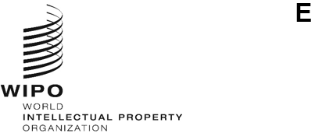
WIPO/CR/GE/24/INF/1
ORIGINAL: English
DATE: March 13, 2024
Virtual Panel on Cross Border Uses in the Educational and Research Sectors
March 15, 2024 (from 12:00 to 15:00, Geneva time)
DRAFT PROGRAM
prepared by the International Bureau of WIPO

12:00 - 12:05 | Welcome by Ms. Sylvie Forbin, Deputy Director General, Copyright and Creative Industries Sector, WIPO
12:05 - 12:10 | Introduction by moderator  Ms. Natalia Reiter, Director, Eyetalk Communications, Geneva
12:10 - 12:15 | Case Study 1: American University of Sharjah  Mr. Thomas Allen Hodge, Associate University Librarian, Technology and Technical Service, Sharjah, United Arab Emirates
12:15 - 12:20 | Case Study 2: University of Szeged  by Mr. Peter Mezei, Professor of Law, Faculty of Law and Political Sciences, Szeged, Hungary
12:20 - 12:25 | Case Study 3: Carthage University  by Ms. Amira Kaddour, Professor, National School of Sciences and Advanced Technologies (ENSTAB), and Former Chair of the Professional Master’s Degree on Innovation Engineering and Technology Transfer, Tunis, Tunisia
12:25 - 12:30 | Case Study 4: Scientific Electronic Library Online (SciELO)  by Ms. Amanda Ramalho, Coordinator, Scielo Books, Sao Paulo, Brazil
12:30 - 12:35 | Case Study 5: University of Guadalajara  by Ms. Sayri Karp Mitastein, Director, University Press, Guadalajara, Jalisco, Mexico
12:35 - 14:00 | Cross-cutting discussions
14:00 - 15:00 | Q&A Session with audience

[End of document]

